Milk house
Improvement Estimator
Users Guide

Funding Provided By:
Legislative – Citizen Commission on Minnesota Resources

June 12, 2014

University of Minnesota, Water Resources Center

USE OF THE GUIDE

This Guide provides guidance to users of the Milk house Improvement Estimator (MWIE)
June 2014 Version. This document is designed to assist the user with data entry and interpretation. A reference list which the spreadsheet is based on is included.

The MWIE June 12, 2014 will be updated based on input from users. If you have any questions or comments, please feel free to contact Sara Heger at the University of Minnesota (sheger@umn.edu). Your comments will allow us to continuously improve the MWIE.

SUPPORT & ACKNOWLEDGEMENTS

Funding for this project was provided by the Minnesota Environment and Natural Resources Trust Fund as recommended by the Legislative-Citizen Commission on Minnesota Resources (LCCMR).

Thanks to the professionals who have provided input to refine the spreadsheet including Kevin Janni and Pete Fryer

AUTHOR

This document and spreadsheet were created by Sara Heger. Please contact her at sheger@umn.edu or 612-625-7243 with questions or comments about the spreadsheet.

Milk House Improvement Estimator (MWIE) Users Guide

BWSR is the Minnesota State Soil and Water Conservation (BWSR) Agency, and it administers programs that prevent sediment and nutrients from entering our lakes, rivers, wetlands, and streams; enhance fish and wildlife habitat; and protect wetlands. BWSR receives appropriations from the Clean Water, Land & Legacy Amendment to pay for on-the-ground conservation projects that provide multiple benefits for water quality and wildlife habitat. Increasingly, BWSR grant funds have been used to upgrade failing milk house wastewater systems. Part of receiving these grants is submitting data about the pollutant load removal and there was previously no standardized approach to reporting these results as required by the legislature. Therefore the Milk House Wastewater Improvement Estimator (MWIE) was developed. It is a spreadsheet-based model that calculates annual pollutant loads from problematic milk house wastewater systems and accounts for the benefits of a range of milk house wastewater improvements. This tool is intended for use on projects where the producers cannot add the milk house wastewater to liquid manure storage. This paper provides an introduction to the MWIE, as well as tips and instructions for using it. This paper accompanies the Microsoft Excel file with the title MWIE_June 2014.xlsx. The Excel file can be downloaded at http://www.bwsr.state.mn.us/outreach/eLINK/ . It can be modified to fit different regulatory requirements and systems across the US.

SECTION 1. ESTIMATOR STRUCTURE AND OVERVIEW

The MWIE has three steps: 1. Calculating Existing Pollutant Loads; 2.Calculating Removals with “Future” or Installed Management Practices (Figure 1). The data is entered in the gold cells and the results are reported in the maroon cells. The gold section of the worksheet summarizes the calculations completed in the maroon data entry section.

Pollutant Removal
Future or Installed New Systems
Existing Pollutant Load

Figure 1. Spreadsheet flowchart.

Contaminants of Concern
Due to their documented impacts to surface and ground water the contaminants of concern addressed in this model are discussed below. There are two values identified for each parameter one for a parlor milking system, the other for a pipeline system. Generally speaking a parlor is an isolated room or separate building to which cows kept on a loose-housing system are taken for milking. On the other hand a pipeline is typically is installed above the cow stalls and the cows are milked in sequence by moving from one cow to the next down the row of stalls. If you are uncertain which type of milking system the system has contact the producer or designer of the system.

Biochemical oxygen demand, five-day(BOD₅) : quantitative measure of the amount of oxygen consumed by bacteria while stabilizing, digesting, or treating biodegradable organic matter under aerobic conditions over a five-day incubation period; expressed in milligrams per liter (mg/L) . Assumed value for milk house wastewater is 1845 mg/l for a parlor milking system and 2141 for a pipeline milking system (Janni et al., 2009).

Solids, total suspended (TSS): measure of all suspended solids in a liquid, typically expressed in mg/L; to measure, a well-mixed sample is filtered through a standard glass fiber filter and the residue retained on the filter is dried to a constant weight at 217 to 221 degrees F (103 to 105 degrees C); the increase in the weight of the filter represents the amount of total suspended solids (CIDWT, 2009). Assumed value for milk house wastewater is 870 mg/l for a parlor milking system and 795 for a pipeline milking system (Janni et al., 2009).

Phosphorus (P): chemical element and nutrient essential for all life forms, occurring as orthophosphate, pyrophosphate (P₂O₇⁻⁴), tripolyphosphate (P₃O₁₀⁵⁻), and organic phosphate forms; each of these forms, as well as their sum (total phosphorus), is expressed in terms of milligrams per liter (mg/L) elemental phosphorus; occurs in natural waters and wastewater almost solely as phosphates; excess levels of phosphorous in fresh surface waters may contribute to eutrophication. Assumed value for milk house wastewater is 74 mg/l for a parlor milking system and 50 for a pipeline milking system (Janni et al., 2009).

Nitrogen (N): essential chemical element and nutrient for all life forms; molecular formula (N2), constitutes 78 percent of the atmosphere by volume; nitrogen is present in surface water and groundwater as ammonia (NH₃), nitrite (NO₂-), nitrate (NO₃-), and organic nitrogen; excess levels of nitrogen in marine areas may contribute to eutrophication. Assumed value for milk house wastewater is 95 mg/l for a parlor milking system and 83 for a pipeline milking system (Janni, et al., 2009).

A summary of the raw wastewater constituent concentrations used in the model is shown in Table 1.

Contaminant | Parlor Value | Pipeline Value
BOD (mg/l) | 1845 | 2141
TSS(mg/l) | 870 | 795
P (mg/l) | 74 | 50
N (mg/l) | 95 | 83

Table 1. Raw wastewater characteristics used in model.

Primary Data Sources
For this spreadsheet to provide accurate estimates of removal of contaminants three key data parameters are needed for each system:
- Estimated flow
- Existing system status – used to calculate existing pollutant load
- Type of new system installed – used to calculate removals

If any of this data is unknown when the user is entering data, the spreadsheet will make assumptions which are described in each section.

Calculating Existing System Pollutant Load
The spreadsheet allows two options for determine the flow of wastewater from the milk house:
- Flow meter data – This is the best option for design a system and evaluating the current pollutant load
- Use the number of cows to estimate the flow using 5 gallons per day per cow

This results in the following values:

Cows | Gallons per Day
25 | 125
50 | 250
75 | 375
100 | 500
125 | 625

Table 2. Gallons per day of estimated wastewater production based on the number of cows.

The user then enters the type of existing system with the choices of discharge:

Previous System Coding
NA = | Not available
1 = | Surfacing to lake, river, stream, wetland or ditch including tile line
2 = | Surfacing to the ground with high probability for runoff (slopes greater than 5%)
3 = | Surfacing to the ground with medium probability for runoff (slopes from 1-5%)
4 = | Surfacing to the ground with low probability for runoff (slopes less then 1%
5 = | Holding Tank/Pump & Haul
6 = | Underground treatment system that is not surfacing

Table 3. Previous system types and code.

If the user does not know the status of the existing system the spreadsheet assumes a value of 1. The tool then determines how much of the pollutant load the existing system was removing using the following percentages
Contaminant | Existing System Status
 | 1 | 2 | 3 | 4 | 5 | 6
BOD₅ | 0 | 0 | 0 | 0.5 | 0.75 | 0.5
TSS | 0 | 0 | 0 | 0.5 | 0.75 | 0.5
Nitrogen | 0 | 0 | 0 | 0.25 | 0.75 | 0.25
Phosphorous | 0 | 0 | 0 | 0.5 | 0.75 | 0.5

Table 4. Removal percentages for existing systems based on system type.

Calculating Reduction in Load with New System
The user enters the type of new system installed. For more information about the design of these systems see: http://www1.extension.umn.edu/agriculture/manure-management-and-air-quality/wastewater-systems/

The option included in this estimator are connecting to large storage device with land application or installing a new milk house wastewater treatment system (MWTS) from the list below:

New System Coding
NA = | Not available
1 = | Bark bed
2 = | Irrigation System
3 = | Holding Tank/Pump & Haul
4 = | Aerobic treatment unit with subsurface treatment system
5 = | Media filter with subsurface treatment system
6 = | Flocculator with subsurface treatment system
7 = | Vegetated Treatment Dosing System

Table 5. New system types and codes.

When a new MWTS is installed the model uses the values in Table 4 to calculate the reduction in contaminants. Most new systems are estimated to remove 100% of the BOD₅ and TSS and phosphorus as they all have a minimum of 2 feet of soil treatment or a pretreatment unit followed by a soil treatment system that in combination will achieve this level of treatment (Bouma, 1979, Heger et al., 2010). There is one acceptation which is a holding tank/pump and haul as there may be times of the year when the effluent is land applied and the effluent may run off. The 100% removal of phosphorus is based on field and laboratory studies documenting phosphorus removal below soil treatment areas (Sawhney, 1977; Bouma, 1979). If the soil treatment system is functioning correctly, and proper setbacks are maintained from surface waters and vertical separation from periodically saturated soil, problems from phosphorus movement to surface water or groundwater should be minimal in most systems and soils in Minnesota.

Nitrogen removal varies by type of system installed. Below ground systems generally do not remove significant amounts of nitrogen and are estimated at 25%. Above ground application is estimated from 50 – 80% with the biggest factors being the potential for runoff and the harvesting of a crop.

Contaminant | New System
 | 1 | 2 | 3 | 4 | 5 | 6 | 7
BOD₅ | 100 | 100 | 75 | 100 | 100 | 100 | 100
TSS | 100 | 100 | 75 | 100 | 100 | 100 | 100
Nitrogen | 25 | 80 | 75 | 25 | 25 | 25 | 80
Phosphorous | 100 | 100 | 75 | 100 | 100 | 100 | 100

Table 6. Removal percentages for new systems.
Calculating Impacts of Management
Under section three of the spreadsheet the model quantifies if the system management will be actively tracked by the local governmental unit. All MWTS shall regularly, but in no case less frequently than annually, have their tanks evaluated to determine if the septic tanks need cleaning and then an evaluation of the remainder of the system. BWSR assumes that when system are installed they are appropriately managed so the system has a long term benefit to the environment. The tool will reduce the removal of contaminants by 25% if the system will not be managed.

SECTION 2. DATA ENTRY OVERVIEW

The MWIE is a simple model with relatively minimal data input. This section describes some components of the MWIE and is designed to facilitate the data input process, as well as some tips for tracking down and avoiding errors in the model.

Color Coding
In order to make data entry easier, cells are coded in two colors: gold and maroon.

GOLD CELLS must be filled in.

MAROON CELLS have been calculated, and typically should not be overridden. They represent “bottom line” calculations, such as load reductions or final loads. If the user wants to override maroon cells he/she must go to the Review Tap and select Unprotect Sheet. NOTE: If the worksheet is manipulated/changed in any way please indicate the change in the worksheet itself under comments.

“Pop-Up” Guidance and Comments
Many pieces of input data require a decision on the part of the user. By clicking on many of the purple cells, a “popup” message will appear with guidance for data values (Figure 2).
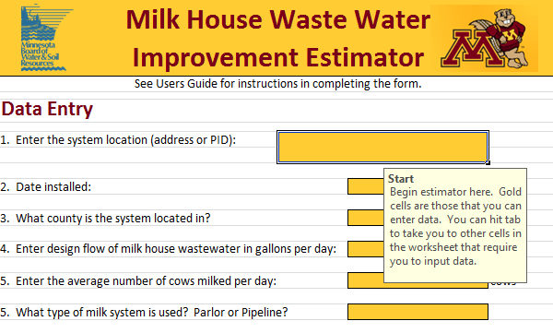
Figure 2. Example of pop-up guidance.

Pull-Down Menus
While many of the data in the MWIE require a number value, some of the inputs are multiple choice such as number of bedrooms or result in a “yes/no”. The MWIE uses “pull down menus” for these questions. For these cells, the user should not (and cannot) select an option that does not appear in the menu (Figure 3).
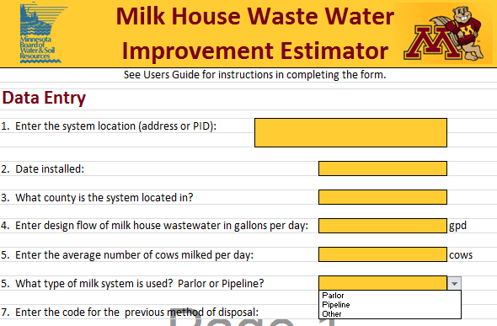
Figure 3. Example of pull-down menu.

Locked Cells
To make the spreadsheet application consistent the non-purple cells are locked/write protected. The other benefit this provides is that the user can “Tab” from purple cell to purple cell during data entry. If the user is applying this model in other applications or needs greater flexibility the worksheets can be unprotected under Review, Unprotect Sheet. NOTE: If the worksheet is manipulated/changed in any way the user is instructed to indicate the change in the worksheet itself under comments.

SECTION 3. DATA ENTRY DETAILS

This section describes in detail the data entry requirements of each section of the MWIE.

- Enter the system location identifier. This can either be the parcel identification number or the address. If at the time of submitting an application the address is unknown enter “Unknown”.
- Enter the date the new system was or will be installed.
- Enter the county the system is located in.
- Enter the design flow of the milk house wastewater treatment system. If you do not know this information contact the designer/engineer for the project.
- Enter the number of cows on average milked per day.
- Enter what type of milking system is used, either a parlor or pipeline, or other.
- Select the appropriate existing disposal system code from the drop down menu as shown in Table 3. If you do not know this information contact the designer/engineer for the project. If this information is unknown by anyone enter “NA”
- Select the appropriate new system code from the drop down menu as shown in Table 5. If you do not know this information contact the designer/engineer for the project. If this information is unknown by anyone enter “NA”.
- The next step is select “Yes” or “No” from the drop down list regarding management. In order to answer this question “Yes” the LGU must have a program to actively track the proper maintenance of systems that are being funded under this project. If the maintenance tracking is left solely up to the property owner enter “No”.

Below in Figure 4 you will see an example of a farm that had a system with 60 cows milked in a parlor which had previously discharged to a ditch and installed an Irrigation System that will be activity managed.

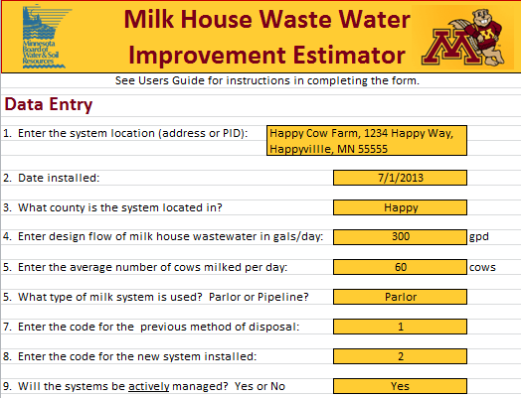

Figure 4. Example diagram of completed data entry for a system.

RESULTS

Under Results from the MWIE are reported. The table provides the additional removal of Biochemical Oxygen Demand, Total Suspended Solids along with the nutrients Nitrogen and Phosphorous based on the data entered after the new system has been installed. The results are all in pounds and tons of contaminant removed Figure 6 below shows the output for the systems inputted in Figure 5.

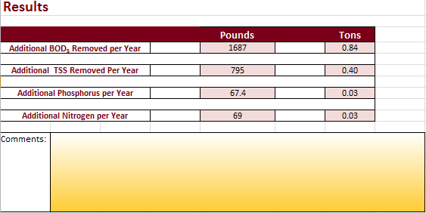
Figure 5. Table of Results.

SUMMARY

The Milk house wastewater improvement estimator is a spreadsheet based tool to estimate the impacts of upgrading milk house wastewater systems. It will be implemented in 2014 in Minnesota and be refined as needed.

LITERATURE CITED
Heger, Sara, F, D.R. Schmidt; K.A. Janni. 2010. Aerobic and Media filter Treatment Systems for Milk House Wastewater on Small Dairy Operations. Applied Engineering in Agriculture. 2010;26(2):319-327.

Janni, Kevin A., S. Heger Christopherson, David R. Schmidt. 2009 Milk House Wastewater Flows and Characteristics for Small Dairy Operations. Applied Engineering in Agriculture. 2009;25(3):417-423.
Magdorf, F.R., D.R. Keeney, J. Bouma, W.A. Ziebell. 1974. Columns Representing
Mound Type Disposal Systems for Milk house wastewater Tank Effluent: Nutrient Transformations and Bacterial Populations. Journal of Environmental Quality. 3(3) p .228-234.

Sawhney, B.L. 1977. Predicting Phosphate Movement Through Soil Columns. Journal of Environmental Quality. 6:86-89.

