Septic System
Improvement Estimator
Users Guide

Funding Provided By:
Legislative – Citizen Commission on Minnesota Resources

November 2017

University of Minnesota, Water Resources Center

USE OF THE GUIDE

This Guide provides guidance to users of the Septic System Improvement Estimator (SSIE)
2013 Version. This document is designed to assist the user with data entry and interpretation. A reference list which the spreadsheet is based on is included.

The SSIE 2013 will be updated based on input from users. If you have any questions or comments, please feel free to contact Sara Heger at the University of Minnesota (sheger@umn.edu). Your comments will allow us to continuously improve the SSIE.

SUPPORT & ACKNOWLEDGEMENTS

Funding for this project was provided by the Minnesota Environment and Natural Resources Trust Fund as recommended by the Legislative-Citizen Commission on Minnesota Resources (LCCMR).

Thanks to the counties and professionals who have provided input to refine the spreadsheet: Dick Hoffman, Chris LeClair, Ryan Lefers, Aaron Jensen, Angie Knish, Chris Pence, Bruce Poppel,
Kellie Strobel and Minnesota Pollution Control Agency’s Subsurface Sewage Treatment System Program, and the Minnesota Subsurface Sewage Treatment System (SSTS) Advisory Committee.

AUTHOR

This document and spreadsheet were created by Sara Heger. Please contact her at sheger@umn.edu or 612-625-7243 with questions or comments about the spreadsheet.

Septic System Improvement Estimator (SSIE) Users Guide

BWSR is the Minnesota State Soil and Water Conservation (BWSR) Agency, and it administers programs that prevent sediment and nutrients from entering our lakes, rivers, and streams; enhance fish and wildlife habitat; and protect wetlands. BWSR receives appropriations from the Clean Water, Land & Legacy Amendment to pay for on-the-ground conservation projects that provide multiple benefits for water quality and wildlife habitat. Increasingly, BWSR grant funds have been used to upgrade failing septic systems. Part of receiving these grants is submitting data about the pollutant load removal and there was previously no standardized approach to reporting these results as required by the legislature. Therefore the Septic System Improvement Estimator (SSIE) was developed. It is a spreadsheet-based model that calculates annual pollutant loads from problematic septic systems and accounts for the benefits of a range of septic system improvements, educational efforts and programs to identify the problematic systems. This paper provides an introduction to the SSIE, as well as tips and instructions for using it. This paper accompanies the Microsoft Excel file with the title 2013 SSIE_April.xlsx. The Excel file can be downloaded at http://www.bwsr.state.mn.us/outreach/eLINK/ . It can be modified to fit different regulatory requirements and systems across the US.

SECTION 1. ESTIMATOR STRUCTURE AND OVERVIEW

The SSIE has three steps: 1. Calculating Existing Pollutant Loads; 2.Calculating Removals with “Future” or Installed Management Practices; 3. Calculating Impact of Education and Trigger Programs (Figure 1). The data is entered in the purple cells and the results are reported in the aqua cells. The aqua page of the worksheet summarizes the calculations completed in the purple data entry section.

Existing Pollutant Load
Educational & Trigger Programs
Future or Installed New Systems
Pollutant Removal
Figure 1. Spreadsheet flowchart.

Contaminants of Concern
Due to their documented impacts to surface and ground water the contaminants of concern addressed in this model are:

Biochemical oxygen demand, five-day(BOD₅) : quantitative measure of the amount of oxygen consumed by bacteria while stabilizing, digesting, or treating biodegradable organic matter under aerobic conditions over a five-day incubation period; expressed in milligrams per liter (mg/L) (CIDWT, 2009). Assumed value for raw wastewater is 420 mg/l (Lowe, et al., 2009).

Solids, total suspended (TSS): measure of all suspended solids in a liquid, typically expressed in mg/L; to measure, a well-mixed sample is filtered through a standard glass fiber filter and the residue retained on the filter is dried to a constant weight at 217 to 221 degrees F (103 to 105 degrees C); the increase in the weight of the filter represents the amount of total suspended solids (CIDWT, 2009). Assumed value for raw wastewater is 232 mg/l (Lowe, et al., 2009).

Coliform bacteria, fecal: indicator bacteria common to the digestive systems of warm-blooded animals that is cultured in standard tests to indicate either contamination from sewage or the level of disinfection provided by a treatment process; generally measured as number of colony forming units (CFU)/100 mL) (CIDWT, 2009). Assumed value for raw wastewater is 1,580,000 CFU (Lowe, et al., 2009).

Phosphorus (P): chemical element and nutrient essential for all life forms, occurring as orthophosphate, pyrophosphate (P₂O₇⁻⁴), tripolyphosphate (P₃O₁₀⁵⁻), and organic phosphate forms; each of these forms, as well as their sum (total phosphorus), is expressed in terms of milligrams per liter (mg/L) elemental phosphorus; occurs in natural waters and wastewater almost solely as phosphates; excess levels of phosphorous in fresh surface waters may contribute to eutrophication (CIDWT, 2009). Assumed value for raw wastewater is 10.4 mg/L (Lowe, et al., 2009).

Nitrogen (N): essential chemical element and nutrient for all life forms; molecular formula (N2), constitutes 78 percent of the atmosphere by volume; nitrogen is present in surface water and groundwater as ammonia (NH₃), nitrite (NO₂-), nitrate (NO₃-), and organic nitrogen; excess levels of nitrogen in marine areas may contribute to eutrophication (CIDWT, 2009). Assumed value for raw wastewater is 60 mg/L (Lowe, et al., 2009).

A summary of the raw wastewater constituent concentrations used in the model is shown in Table 1.

Contaminant | Value
BOD (mg/l) | 420
TSS(mg/l) | 232
Fecal(CFU) | 1,580,000
P (mg/l) | 10.4
N (mg/l) | 60

Table 1. Raw wastewater characteristics used in model.

Primary Data Sources
For this spreadsheet to provide accurate estimates of removal of contaminants three key data parameters are needed for each system:
- Number of bedrooms – used to estimate flow
- Existing system status – used to calculate existing pollutant load
- Type of new system installed – used to calculate removals

If any of this data is unknown when the user is entering data, the spreadsheet will make assumptions which are described in each section.

Calculating Existing System Pollutant Load
The spreadsheet uses the number of bedrooms entered by the user and applies Class II flows using the following equation from Minnesota Rules Chapter 7080.1860:

(Number of bedrooms + 1) X 75 gallons

This results in the following values:

Bedrooms | Gallons per Day
2 or less | 225
3 | 300
4 | 375
5 | 450
6 | 525
Table 2. Gallons per day of estimated wastewater production based on the number of bedrooms.

A 1 bedroom dwelling is not allowed as MN Rules Chapter 7080 requires that every home be designed for at least 2 bedrooms. Using Class II flows is a better estimator of actual flows (Mayer, 1999). If the number of bedrooms is unknown the spreadsheet assumes 3 with a flow of 300 gpd. It is understood that the number of bedrooms is not a good indicator of flow, but this is the typical data available.

The user then enters the type of existing system with the choices of imminent public health or safety threat (IPHST) either with or without a managed septic tank, failing to protect groundwater (FPG) or not available (NA).

From Chapter 7080.1500, Subp. 4, a system that is not protective is considered an imminent threat to public health or safety. At a minimum, a system that is an imminent threat to public health or safety is a system with:
- a discharge of sewage or sewage effluent to the ground surface, tile drainage systems, ditches, or storm water drains or directly to surface water;
- reoccurring sewage backup into a dwelling or other establishment;
- electrical hazards; or
- sewage tanks with unsecured, damaged, or weak maintenance hole covers or weak lids.

According to Minnesota Rules Chapter 7080.1500, a system is failing to protect groundwater if it is:
1. a seepage pit, cesspool, drywell, leaching pit, or other pit;
2. a system with less than the required vertical separation distance;
3. a system that is no longer in use and is not abandoned properly.

If the user does not know the status of the existing system the spreadsheet assumes an IPHT. In order for the user to select managed septic tank, maintenance records for the last 10 years must be available documenting proper maintenance of the septic tank otherwise the unmanaged option should be selected. The SSIE then takes the existing system code entered by the user to calculate the load of each of contaminants prior to installation of the new system based on the estimated reductions shown in Table 3.

If the system is complaint the model assumes the system is an in-ground Type I system. Some compliant systems outside for shoreland and wellhead projection areas and those not serving food beverage and lodging establishments are considered compliance with 2 feet of separation. Systems with 2 feet of separation will not have as high of removals of fecal coliform, nitrogen and phosphorus.
Contaminant | Existing System Compliance Status
 | A. IPHT No Septic Tank | B. IPHT with Managed Septic Tank | C. Failing to Protect Ground-Water | D. Compliant SSTS w/ 3 ft of Soil Treatment | E. Compliant SSTS w/ 2 ft of Soil Treatment
BOD₅ | 0 | 50% | 75% | 100% | 100%
TSS | 0 | 50% | 75% | 100% | 100%
Fecal/E-Coli | 0 | 0 | 50% | 100% | 50%
Nitrogen | 0 | 5% | 10% | 25% | 10%
Phosphorous | 0 | 5% | 50% | 100% | 50%
Table 3. Removal percentages for existing systems based on compliance status.

Calculating Reduction in Load with New System
The user enters the type of new system installed. The options are connecting to a wastewater treatment plant or installing a new subsurface sewage treatment system (SSTS) with one of the following classifications:
- Type I
  - Trench, bed or at-grade (MN Rules Chapter 7080.2210 and 7080. 2230),
  - Mound (MN Rules Chapter 7080.2220)
- Type II
  - Holding tank (MN Rules Chapter 7080.2290)
- Type III (Most common are Type I systems built on damaged or disturbed soils)
  - Trench, bed or at-grade (MN Rules Chapter 7080.2210 and 7080.2230),
  - Mound (MN Rules Chapter 7080.2220)
- Type IV
  - Registered to NOT remove nitrogen (MN Rules Chapter 7080.2350)
  - Registered to remove nitrogen to < 20 mg/l (MN Rules Chapter 7080.2350 and 7083.4030
- Type I installed under an alternative local standard with less than 3 feet of soil treatment.
If the existing system is being hooked up to a WWTP the user enters the discharge limits allowable under their MPCA permit. Some WWTP may not have a nitrogen limit. Surface water discharges are evaluated based on low flow in the stream. Ammonia, in particular has toxicity concerns for aquatic life. When the ratio of low flow to wastewater gets around 10:1, the facility likely has an effluent ammonia limit. This means that a majority of the ammonia will be converted to nitrate which is not toxic to fish. Streams with cold water fish species like trout, will likely get an ammonia limit regardless of flow ratio. Therefore, commonly, WWTPs have ammonia limits but no requirement for overall nitrogen reduction.
If a new SSTS system is installed the model uses the values in Table 4 to calculate the reduction in contaminants. All new systems are estimated to remove 100% of the BOD₅ and TSS (Magdorf et al., 1974) as they all have a minimum of 2 feet of soil treatment or a pretreatment unit followed by a soil treatment system that in combination will achieve this level of treatment.
Nitrogen removal varies by type of system installed. Mound systems facilitate nitrogen removal and typically reduce nitrogen concentrations by 32 to 70% (Magdorf et al., 1974; Eastburn and Ritter, 1984). Additional studies have shown little total nitrogen removal beneath thirty-one at-grade systems in Wisconsin (Converse et al., 1991) and moderate rates of removal (7-15%) in laboratory studies (Van Cuyk et al., 2001). Therefore mound systems and Type IV systems with nitrogen reduction are estimated to remove 50% of the total nitrogen due to their aerobic treatment followed by the conditions conducive to denitrification while remaining systems are only given a 25% reduction.

The 100% removal of phosphorus is based on field and laboratory studies documenting phosphorus removal below soil treatment areas (Sawhney, 1977; Bouma, 1979). If the soil treatment system is functioning correctly, and proper setbacks are maintained from surface waters and vertical separation from periodically saturated soil, problems from phosphorus movement to surface water or groundwater should be minimal in most systems and soils in Minnesota.

Holding tanks are assumed to remove 100% of the contaminants as a majority of this waste is land applied in Minnesota where the sewage is limed to kill off pathogens and nutrients are utilized in crop production.

Type I systems installed under Alternative Local Standards (ALS) which do not require three feet of separation are estimated to only remove 50% of the fecal coliform, 10% of the nitrogen and 50% of the phosphorus due to the reduced aerobic zone for treatment under unsaturated conditions.

Contaminant | New System
 | Type I or Type III: Trench, Bed, or At-Grade  Type IV: with no N Reduction | Mound or Type IV with Nitrogen Reduction | Holding Tank | Type I SSTS Alternative Local Standard
BOD5 | 100% | 100% | 100% | 100%
TSS | 100% | 100% | 100% | 100%
Fecal/E-Coli | 100% | 100% | 100% | 50%
Nitrogen | 25% | 50% | 100% | 10%
Phosphorous | 100% | 100% | 100% | 50%

Table 4. Removal percentages for new systems.

Calculating Impacts of Management, Education and Triggers
Under section three of the spreadsheet the model quantifies if the system management will be actively tracked by the local governmental unit (LGU). According to MN Rules Chapter 7080.2450, all SSTS must be managed. All SSTS shall regularly, but in no case less frequently than every three years assess whether sewage tanks leak and measure or remove the accumulations of scum, grease, and other floating materials at the top of each septic tank and compartment, along with the sludge, which consists of the solids denser than water. For Type II, III and IV systems the activities are often more extensive and at shorter intervals. This requirement falls on the property owner, although some LGUs have management programs which track and enforce this requirement. This is a positive impact for the long term treatment and longevity of the SSTS as documented by the Ottertail Water Management District (Christopherson and Anderson, 2008).

Section four of the spreadsheet computes the impacts of educational and triggers programs initiated by the LGU. Homeowner education is a positive influence on the long-term treatment and longevity of the SSTS. The triggers in the spreadsheet are varying programs that LGUs use to identify and correct problematic systems in their jurisdiction. The rationale behind these credits is that some LGUs are working very hard to identify and fix problem systems and keep existing systems in compliance. These LGUs often have properties where the owners cannot afford to upgrade their systems; therefore the model ranks these projects slightly higher. The spreadsheet rewards triggers as shown in Table 5. These percentages either reduces or increases the load reductions depending on if they are positive (increase) or negative (decrease).

 |  |  |  | Impact
Lack of Management Program |  |  |  | -10%
Homeowner Education Program |  |  |  | +2%
Comprehensive County Inventory Project |  |  |  | +2%
Target Area Inventory Projects/TDML |  |  |  | +1%
Property Transfer |  |  |  | +1%
Shore land Permit Request |  |  |  | +1%
Any Building Permit Request |  |  |  | +1%
Other |  |  |  | +0.5%
Table 5. Impacts of management, education and trigger programs.

SECTION 2. DATA ENTRY OVERVIEW

The SSIE is a simple model with relatively minimal data input. This section describes some components of the SSIE and is designed to facilitate the data input process, as well as some tips for tracking down and avoiding errors in the model.

Color Coding
In order to make data entry easier, cells are coded in two colors: purple and aqua.

PURPLE CELLS must be filled in.

AQUA CELLS have been calculated, and typically should not be overridden. They represent “bottom line” calculations, such as load reductions or final loads. If the user wants to override aqua cells he/she must go to the Review Tap and select Unprotect Sheet. NOTE: If the worksheet is manipulated/changed in any way please indicate the change in the worksheet itself under comments.

“Pop-Up” Guidance and Comments
Many pieces of input data require a decision on the part of the user. By clicking on many of the purple cells, a “popup” message will appear with guidance for data values (Figure 2).

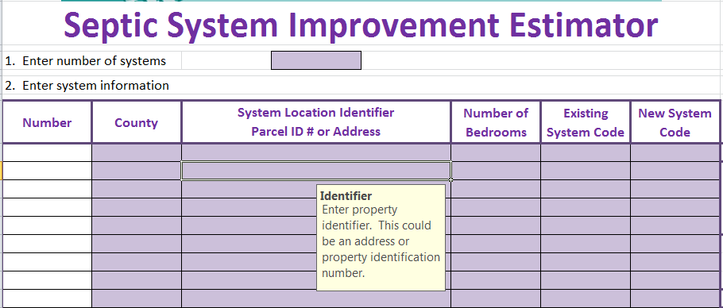

Figure 2. Example of pop-up guidance.

Pull-Down Menus
While many of the data in the SSIE require a number value, some of the inputs are multiple choice such as number of bedrooms or result in a “yes/no”. The SSIE uses “pull down menus” for these questions. For these cells, the user should not (and cannot) select an option that does not appear in the menu (Figure 3).

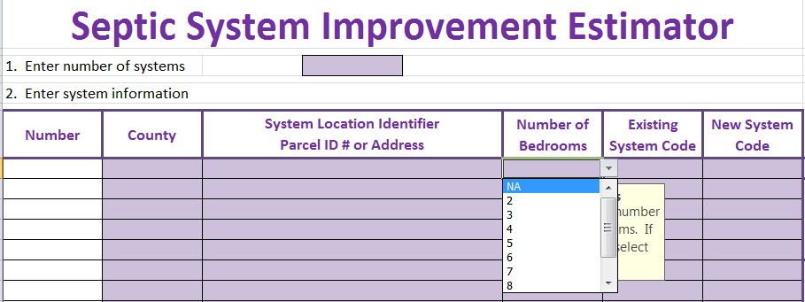

Figure 3. Example of pull-down menu.

Locked Cells
To make the spreadsheet application consistent the non-purple cells are locked/write protected. The other benefit this provides is that the user can “Tab” from purple cell to purple cell during data entry. If the user is applying this model in other applications or needs greater flexibility the worksheets can be unprotected under Review, Unprotect Sheet. NOTE: If the worksheet is manipulated/changed in any way the user is instructed to indicate the change in the worksheet itself under comments.
SECTION 3. DATA ENTRY DETAILS

This section describes in detail the data entry requirements of each section of the SSIE.

- Enter number of systems.
Begin estimator here. You can hit “Tab” to take you to the other cells in the worksheet that require you to input data. The model can calculate the load reduction for up to 15 systems. If you have more than 15 systems you could either use two spread sheets or contact sheger@umn.edu if assistance is needed in modifying the worksheet. Once the number is added Column A is auto filled with the number of systems (Figure 4).

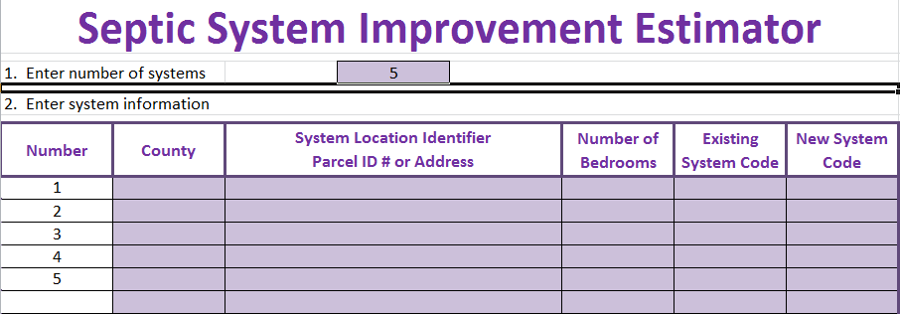

Figure 4. Example of data entry – number of systems.

- Enter the system information.
- Enter county or counties systems are located in. This is required information for Board of Soil and Water Resources (BSWR) projects. If the systems are all located in the same county you can enter the county into the first cell, highlight all the remaining cells and hit “Ctrl” and “D” and the rest of the cells will be auto-filled.
- Enter the system location identifier. This can either be the parcel identification number or the address. If at the time of submitting an application the address is unknown enter “Unknown”.
- Enter the number of bedrooms for each property. If it is unknown select NA from the drop down list. The drop down list includes up to 10 bedrooms.
- Select the appropriate existing system code from the drop down men as shown in Table 6.

Existing System Coding
NA = | Not available
1 = | Imminent Public Health or Safety Threat
2 = | Imminent Public Health or Safety Threat with Managed Septic Tank
3 = | Failing to Protect Groundwater
4 = | Compliant System with 3 feet of separation
5 = | Compliant System with 2 feet of separation

Table 6. Coding for existing system status.

- Select the appropriate new system code from the drop down men as shown in Table 7.

New System Coding
NA = | Not available
1 = | Type I or Type III: Trench, Bed, or At-Grade, Type IV: with no Nitrogen Reduction
2 = | SSTS Mound or Nitrogen reducing Type IV
3 = | Holding Tank
4 = | SSTS with Alternative Local Standard < 3 feet on Type I systems
5 = | Hooked up to Wastewater Treatment Plant

Table 7. Coding for new system status.

If any of the systems use the code “5” Hooked up to Wastewater Treatment Plant you must then go to the table below and enter the discharge limits of the WWTP. The user should be able to obtain these limits from the WWTP or the Minnesota Pollution Control Agency who is the permitting authority. If some of the values are not permitted or available leave those cells blank.

Below in Figure 5 is an example showing 6 systems with the data entered through step 2e.

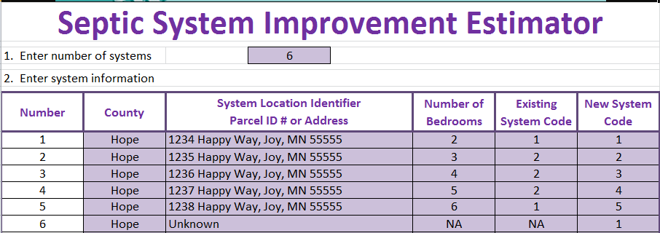

Figure 5. Example of data entry of system information.
Items 3 and 4, the management, education and trigger programs questions, can NOT be left blank or the SSIE will not calculate the reductions.

- The next step is select “Yes” or “No” from the drop down list regarding management. In order to answer this question “Yes” the LGU must have a program to actively track the proper maintenance of systems that are being funded under this project. If the maintenance tracking is left solely up to the property owner enter “No”.
- Enter “Yes” or “No” to each of the educational and trigger programs.

RESULTS

Under number 5 the results from the SSIE are reported. The table provides the additional removal of Biochemical Oxygen Demand, Total Suspended Solids, and Bacteria measured as Fecal Coliform, along with the nutrients Nitrogen and Phosphorous based on the data entered after the new system has been installed. The total removal is summarized for all the systems at the bottom. The results are all in pounds of contaminant removed except for bacteria removed per year which is reported in units of colony forming units (CFU) and in scientific units. For example: 5.01 E+13 correspond to 5.01 with the decimal point moved 13 places to the right or 50,100,000,000,000. Figure 6 below shows the output for the systems inputted in Figure 5.

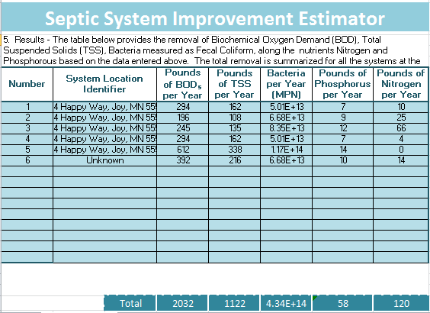
Figure 6. Table of Results.

SUMMARY

The septic system improvement estimator is a spreadsheet based tool to estimate the impacts of upgrading septic systems. It will be implemented in 2014 in Minnesota and be refined as needed.

LITERATURE CITED

Boom, J., 1979. Subsurface Applications of Sewage Effluent. In: Planning the Uses and Management of Land. M.T. Beatty, G.W. Petersen and L.D. Swindale (Eds.). Agronomy
21. Am. Soc. of Agronomy. Madison, WI. pp. 665-703.

Christopherson, S. and J. Anderson. 2004. Twenty Years of Successful Onsite Wastewater Management – The Otter Tail, Minnesota Water Management District. In Proceedings of the 2004 National Onsite Wastewater Recycling Association (NOWRA) Conference, Albuquerque, NM.

CIDWT Decentralized Wastewater Glossary. 2009. Available online at:
http://www.onsiteconsortium.org/glossary.html

Converse, J.C., M.E. Kean, E.J. Tyler and J.O. Peterson. 1991. Bacterial and Nutrient
Removal in Wisconsin At-grade On-site Systems. In: On-site Wastewater Treatment. Proceedings of the Sixth National Symposium on Individual and Small Community Sewage
Systems. American Society of Agricultural Engineers. St. Joseph MI. pp. 46-61.

Eastburn, R.P. and W.F. Ritter. 1984. “Denitrification in On-site Wastewater Treatment Systems - a Review,” in On-site Wastewater Treatment. Proceedings of the 4th National Symposium on Individual and Small Community Sewage Systems. New Orleans, LA, Dec. 10-11, 1984. Am. Soc. of Ag. Engineers.

Lowe, K.S., M Tucholke, J. Tomaras, K. Conn, J. Drewes, J. McCray, and J. Munakata-Marr. 2009. Influent Constituent Characteristics of the Modem Waste Stream from Single Sources. 04-DEC-1.

Magdorf, F.R., D.R. Keeney, J. Bouma, W.A. Ziebell. 1974. Columns Representing
Mound Type Disposal Systems for Septic Tank Effluent: Nutrient Transformations and Bacterial Populations. Journal of Environmental Quality. 3(3) p .228-234.

Mayer, P.W., W.B. DeOreo, E.M. Opitz, J.C Kiefer, WY. Davis and B Dziegielewski. 1999. Residential End Uses of Water. AWWA Research Foundation and the American Water Works Association. Denver, CO.
Minnesota Pollution Control Agency. 2011. Subsurface Sewage Treatment System Standards: Chapter 7080 and 7083 MN Rules. Minnesota Pollution Control Agency, Water Quality Div., St. Paul, MN 55155.
Sawhney, B.L. 1977. Predicting Phosphate Movement Through Soil Columns. Journal of Environmental Quality. 6:86-89.

Van Cuyk, S., R. Siegrist, A. Logan, S. Masson, E. Fischer and L. Figueroa. 2001. Hydraulic and Purification Behaviors and Their Interactions During Wastewater Treatment in Soil Infiltration Systems, Water Res. 35(4), pp. 101-110.

